Ratio word problems
The ratio of Boys to Girls in class 3 is 1 : 2 for every 1 boy there are 2 girls. Fill in the grid below.
Boys | Girls
1 | 2
2
3
5
10
15
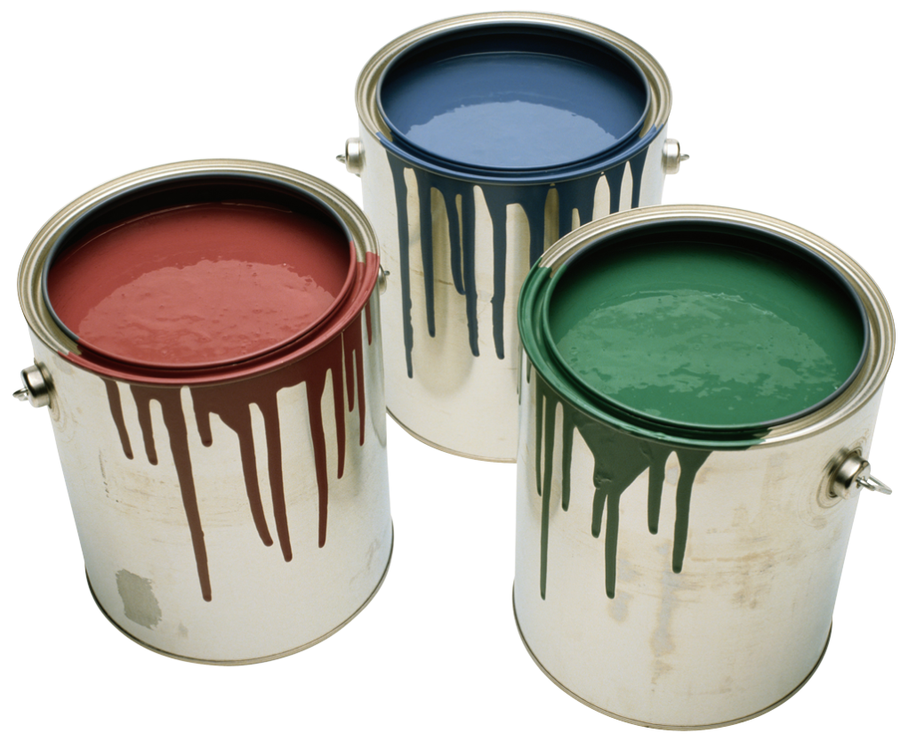
Mixing purple paint – for every 1 tin of blue paint we need 3 tins of red paint. Ratio 1:3. Fill in the grid below
Blue paint | Red paint
1 | 3
2
3
5
10
100
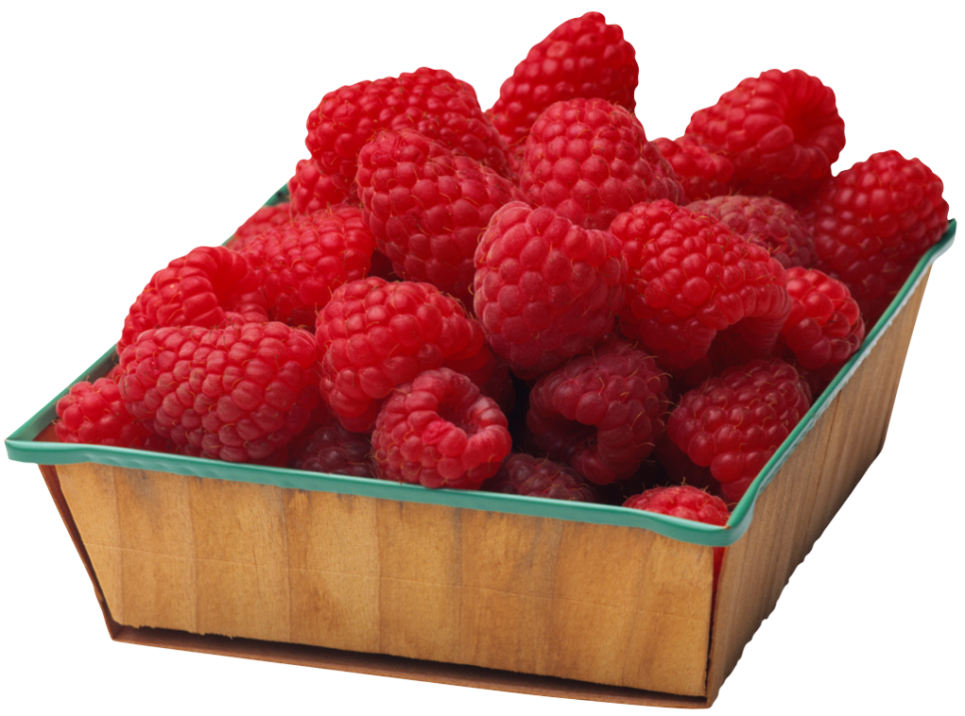
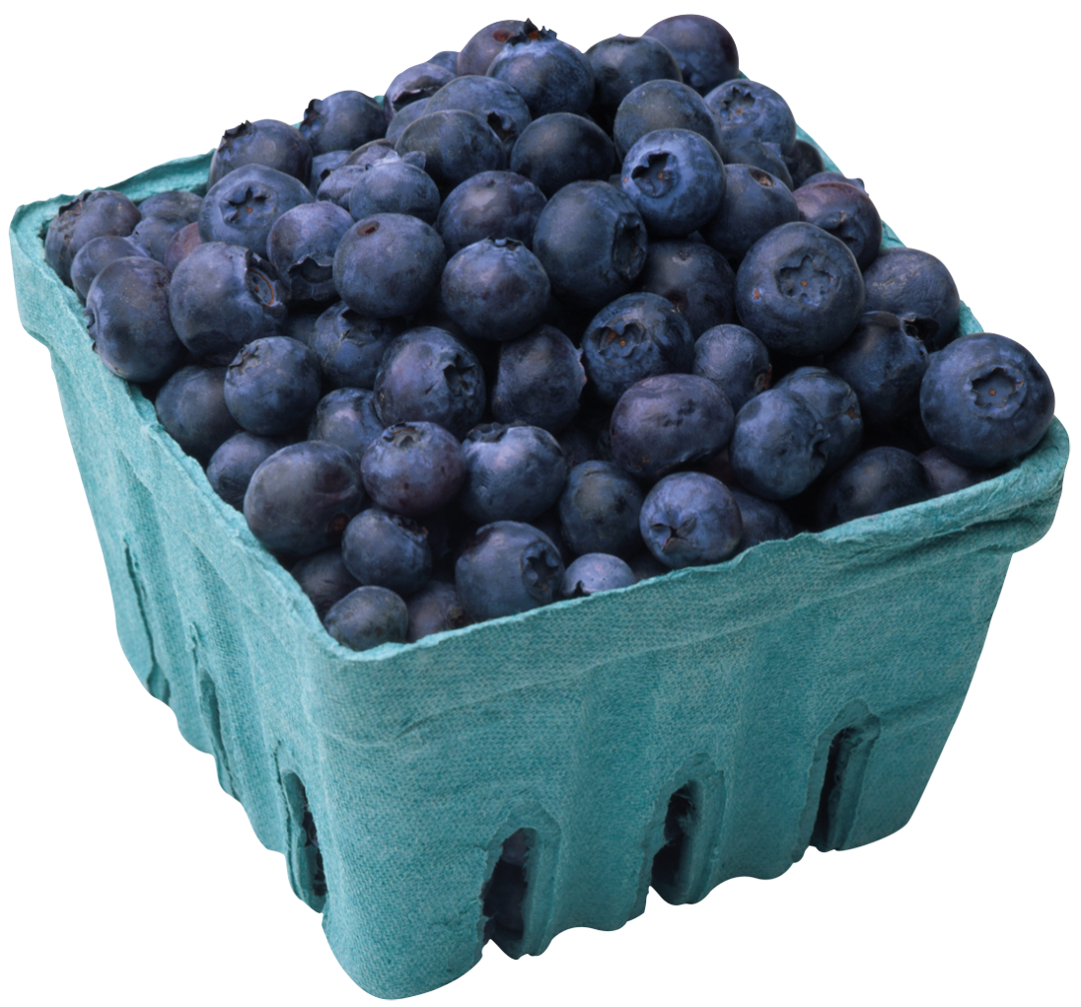
Smoothies ! for every 1 raspberry there are 5 blueberries. 1:5
raspberry | blueberry
1
2
5

