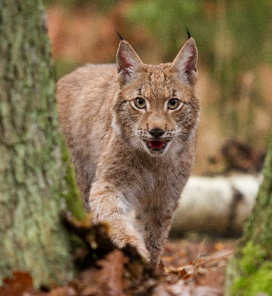

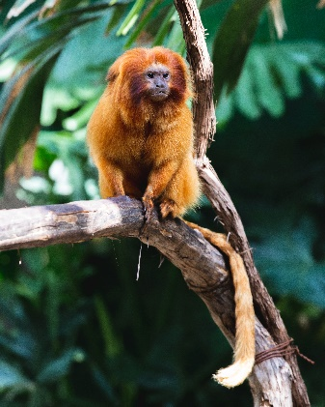

**Marmoset**

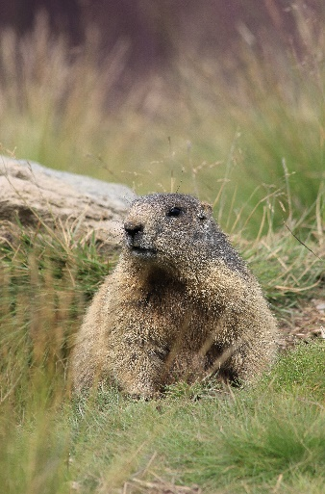

**Marmot**

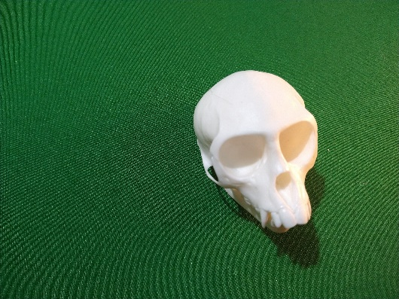

**Skull 3**

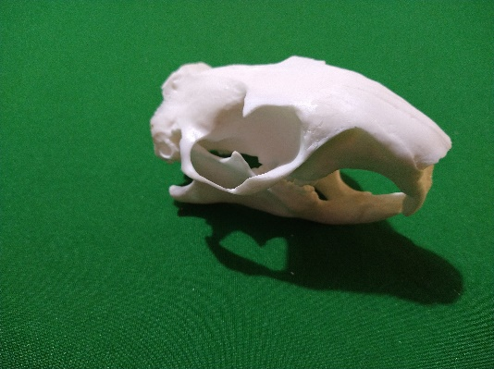

**Skull 2**

**Carnivore**

**(eats other animals)**

**Herbivore**

**(eats plants)**

**Herbivore – eats plants**

**Omnivore**

**(eats plants and other animals)**

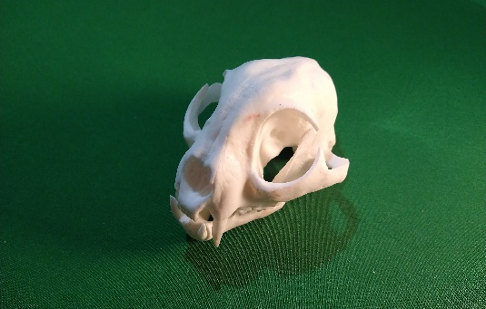

**Skull 1**

**Lynx**