Scorpions

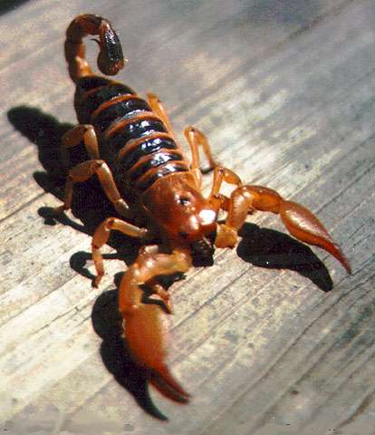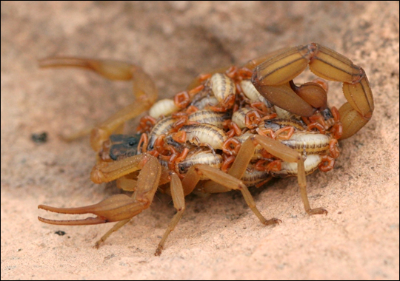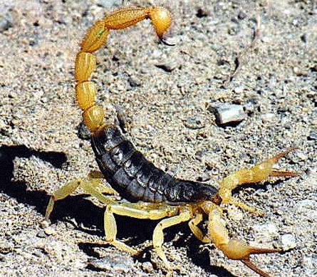

Adult scorpion.

Yellow-tailed scorpion.

Mother scorpion with brood on its back.

Scorpions live all over the world, but mostly in dry, warm areas. Like spiders, they are arachnids and have eight legs. Scorpions have a pair of venom (poison) glands in their stinger; this is what they use for hunting. Scorpion venom is meant for animals so most are not harmful to humans.

**\*How are baby scorpions looked after?**

Scorpions are born one by one, and the brood (the babies) are carried on the mother’s back until they are old enough to look after themselves. This is after they have shed their first skin. Depending on the type of scorpion, the mother might have 100 young scorpions to take care of!

\* Do you get scorpions in Europe?

The European yellow-tailed scorpion is found in warm European countries like Italy or Portugal. It is quite small (about 5cm) and eats insects. As global warming is causing the temperature in many countries to get warmer, colonies (nests) of scorpions have been found in the United Kingdom.

Fun Facts!

* The emperor scorpion can grow 18cm long and is one of the largest in the world.
* The deathstalker scorpion may be the most poisonous scorpion.
* Scorpions can eat insects, small lizards, snakes and mice.