Parent/Carer information leaflet
The Oxford Owl eBook Library contains a wide selection of books from across Oxford’s most popular series. The books are carefully levelled and progress in reading difficulty from those appropriate for Reception right through to those suitable for Year 6. The exact number of books and range of levels your child has access to will depend on the subscription that their school has bought.
How does my child access the eBook Library?
- Go to www.oxfordowl.co.uk
- Click on the ‘Log in’ link (top right) to open the login form.
- Make sure the 'Students' tab is highlighted. Type in the class name and password that your child’s teacher has given your child, and click ‘Login’.
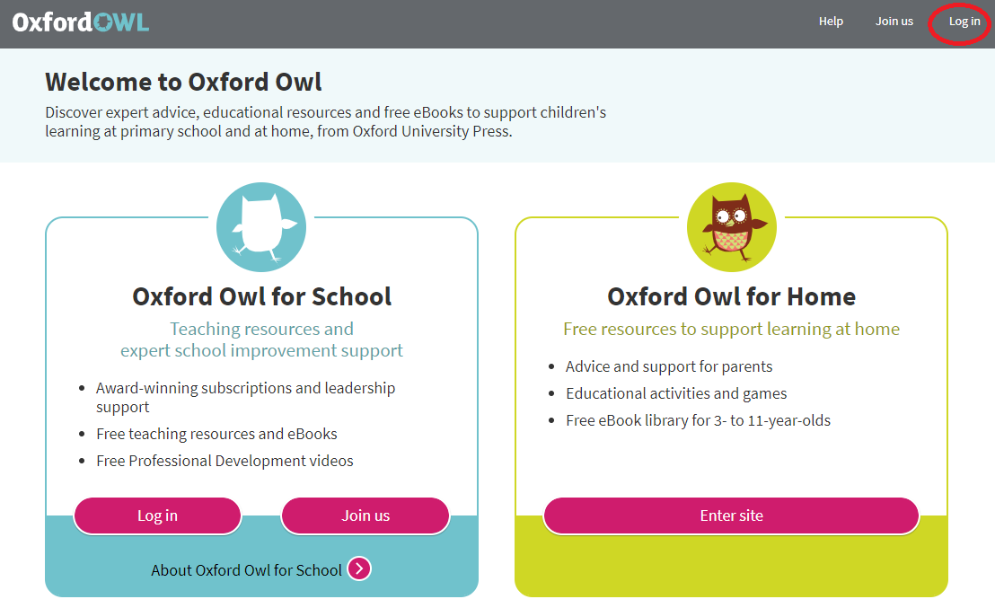
Write your class name and password here:
Class name: ClassL3
Password: Dawley
- Click on the tile for the Oxford Owl eBook Library.
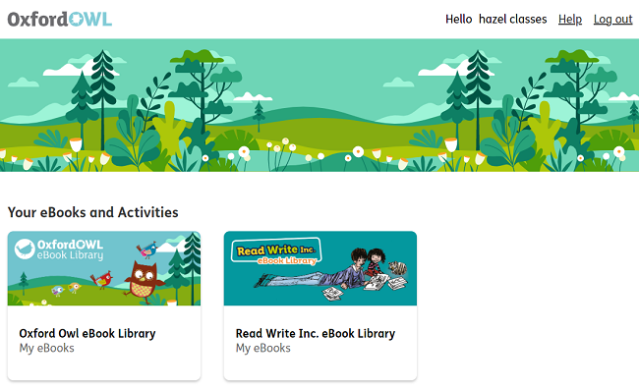
- Click on the eBook to open it.
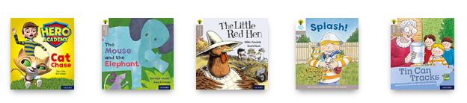
How do I know which book my child should read?
Your child’s teacher will tell them which Oxford Level (or Book Band) they are working on. Your child can then read any of the books at
that level.

Alternatively, your child’s teacher may specify an exact title.

How do I find the right book or level?
To find the right level, click on the Levels filter at the top of the
library, choose Oxford Levels or Book Bands as appropriate. Choose
your level and then the books will be filtered so that you only see
books at that level.
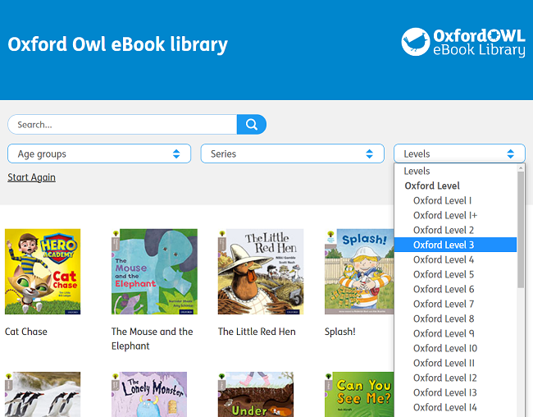

To find the right title, type it into the Search box.
