Match the number sentences to the correct number.
10 + 7 |  | 10 + 4 |  | 20 + 0 |  | 20 + 5
20 |  | 14 |  | 25 |  | 17

Complete the part-whole and write two number sentences to match.
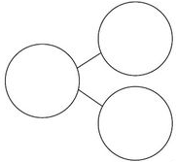
____ + ____ = ____
____ + ____ = ____

____ + ____ = ____
____ + ____ = ____

Hattie has 20 sweets and Noah has 15 sweets.
Represent the total number of sweets: | With concrete resources | 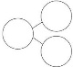  In a part whole model | As a number sentence  __ + __ = __
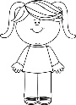

Hattie
20 sweets

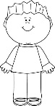

Noah
15 sweets

Fill in the missing numbers.
0 tens and 3 ones = 3
1 ten and ___ ones = 13
2 tens and 3 ones = ___
___tens and 3 ones = 33

What is the next calculation in the pattern?
___tens and ___ ones = ___

