Match the number sentences to the correct number.
30+11 |  | 10 + 4 |  | 40 + 0 |  | 80 + 1
40 |  | 14 |  | 81 |  | 41

Complete the part-whole and write four number sentences to match.
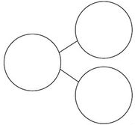
____ + ____ = ____
____ + ____ = ____

____ = ____ + ____

____ + ____ = ____
____ + ____ = ____

____ = ____ + ____

Hattie has 20 sweets and Noah has 15 sweets.
Represent the total number of sweets: | With concrete resources | 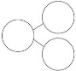  In a part whole model | As a number sentence
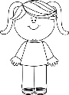

Hattie
20 sweets

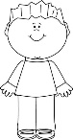

Noah
15 sweets

Fill in the missing numbers.
1 ten and 3 ones = 13
2 tens and ___ ones = 23
3tens and 3 ones = ___
___tens and 3 ones = 43

What are the next calculations in the pattern?

