Self assessment
LO: Identify nouns
Nouns
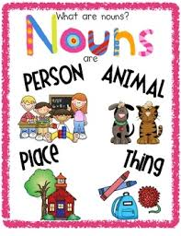
A noun is a:
Person

Place
Thing
Animal

Example: The Queen

NOUNS

Self assessment
Nouns
LO: Identify nouns
A noun is a:
Person

Place
Thing
Animal

Use the nouns from your word map in sentences.

