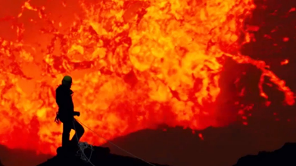
Is Humanity the Next Supervolcano? – KS1 Comprehension
https://www.youtube.com/watch?v=rbHk1ehQJSY

- The Earth has experienced only three mass extinction events. Is this statement true of false? Circle the correct answer.
True / False
- Which of the following is the correct definition for the word ‘extinction’? Tick one.
- The process of a species dying out or disappearing forever.
- The process of a volcano erupting.
- The process of an animal starting to stink.
- The process of humans taking over the world.
- What has caused most of the mass extinction events on Earth?
Most extinction events have been caused by ___________________________________________________.
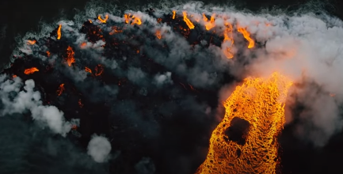
- Can you think of three adjectives to describe this image?
- ____________________________________________
- ____________________________________________
- ____________________________________________
- Which invisible gas is released by volcanic eruptions?
The invisible gas released by volcanic eruptions is called __________________________________________.
- Scientists believe the greatest volcanic eruption in history warmed the planet by how much? Tick one.
- 1°C
- 0.1°C
- 10°C
- 100°C
- What percentage of life on Earth was lost during the greatest mass extinction event in history?
- 10%
- 50%
- 90%
- 100%
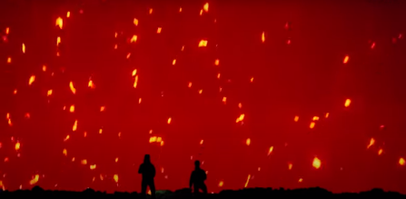
- Pick a word to describe the people here. Explain your choice.
My chosen word is ___________________ because __________________
____________________________________________________________
____________________________________________________________.

EXT: Have a go at making your own erupting volcano using this guide from the Natural History Museum - https://www.nhm.ac.uk/discover/how-to-make-a-volcano.html
Answers
- False.
- The process of a species dying out or disappearing forever.
- Volcanic eruptions.
- Various possible answers – powerful/scary/hot/dark/etc…
- Carbon dioxide.
- 10°C.
- 90%.
- Various possible answers with explanation – brave/crazy/adventurous/etc…

