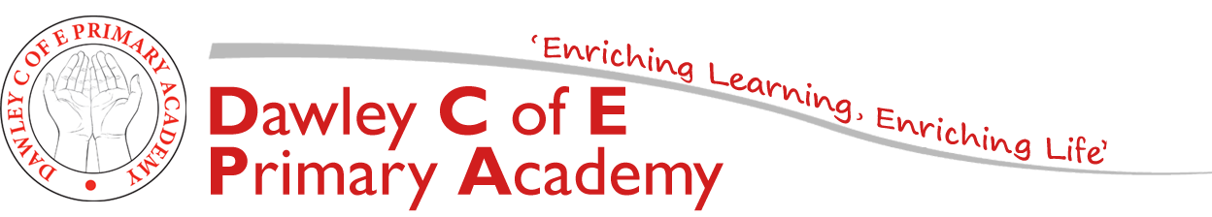
Spring 2

Year 1: Homework

Enjoy books and love reading
Year 1 pupils are expected to read at least 3 times a week and have it recorded in individual reading diaries. (This could be a school book, a book at home, magazine or comic). Children who read three times a week or more at home, will win a prize on Friday. Reading must be recorded in their reading diaries for them to win a prize.
Quicken mental maths skills
Numbots or Times Tables Rock Stars should be accessed for at least 15 minutes per week. Logins are in reading diaries and have also been issued via Class Dojo.
Themed Homework Activities
The tasks cover a range of different areas of learning and vary in the level of adult input required. They are all based on our topic and will enhance the work we complete in class. The homework book is to be handed in at the end of this half term on Tuesday 30th March 2021 so that we can celebrate all homework completed so far. If you need any ideas/materials to complete any tasks, please ask. Thank you for your continued support.
Mrs Breeze
Task 1:  Literacy:  Keep practising phonics.  Samuel Pepys kept a diary of events during The Great Fire of London. Keep your own diary for a weekend and write about all the things you do. | Task 2:  Maths:  Practise number bonds to 10 and 20,  Access Numbots or TTRS, 15 minutes per week.  Who will be our high scorer each week? | Task 3:  Science:  Have a go at baking something you could sell in bakery. Take a picture of the final product to show us.  Think about the measurements involved and what you used.
Task 4:  Geography:  Look around you and find things that are in place to prevent fire spreading e.g. smoke detectors.  Design a poster to promote fire safety. Get together as a family and create an escape plan for your home | Spring 2 Topic  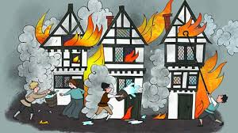  Time Travellers! | Task 5:  Art:  Create a model of 1666 London on fire! Include houses, smoke and flames. You may also include part of the River Thames and The Tower of London in it.
Task 6:  RE:  Compare Sikhism and Christianity. You could look at places of worship, Practices, founder, place of origin. | Task 7:  Reading:  Research the Great Fire of Edinburgh in 1824. How was it similar and different to the Great Fire of London 1666? Compare the homes and technology used. | Task 8:  History:  Create a timeline about a famous person or all about you. Predict what might happen to you in the future.

