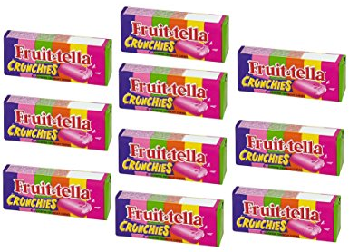
James has 10 sweets.
He gives half of them to his friend.
How many do they each have?
The whole is ____. Half of ____ is ____.

Use counters to find half of the amounts. Complete the stem sentences for each amount.
The whole is ____.  Half of ____ is ____. | The whole is ____.  Half of ____ is ____.
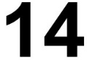  The whole is ____.  Half of ____ is ____. | 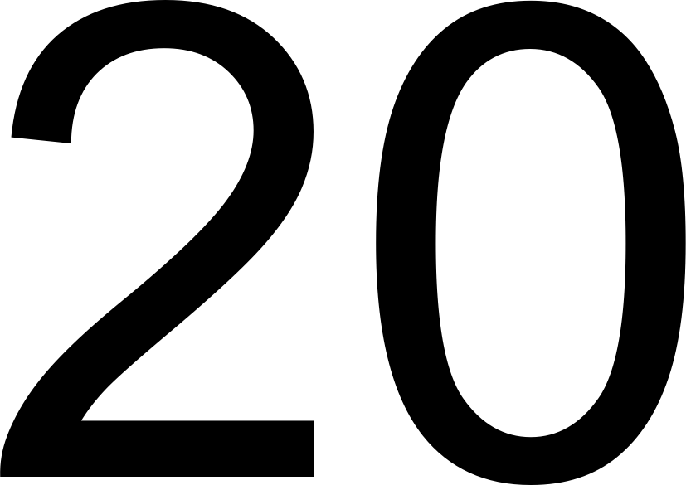  The whole is ____.  Half of ____ is ____.

Fill in the blanks. Use counters and plates to help you if needed.
½ of 4 = ___ | ½ of ___ = 4
½ of 6 = ___ | ½ of ___ = 6
½ of 8 = ___ | ½ of ___ = 8

What do you notice?
__________________________________________________________________________________

