2019/20 Topic Overview (Cycle 2)
Year 5 and 6
 | Cycle 2  2019-2020 | Key texts | WOW!
Autumn 1 | 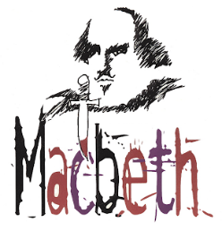 | 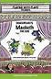  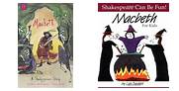  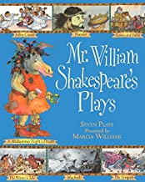 | Roald Dahl Day Chasewater  Macbeth performance  Samaritans visitor.
Autumn 2 | Dickens’ A Christmas Carol  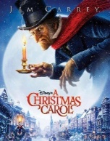 | 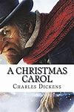 | Trip to The Houses of Parliament
Spring 1 | Refugees  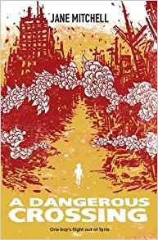 | 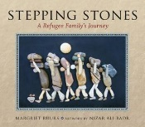 | Amnesty International visitor.
Spring 2 | Hitchhiker’s Guide to the Galaxy  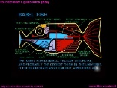 | 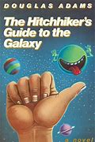 | Telford Sings  Trip to the National Space Centre
Summer 1 | Fieldwork, local study.  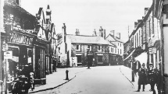 | 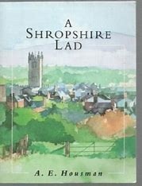  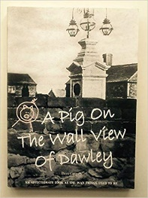  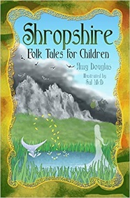 | Geocaching  STAR project.
Summer 2 | Mayan civilisation  and end of year performance  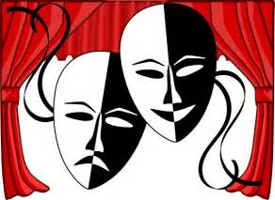 | 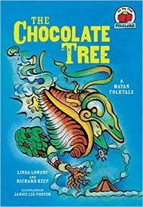  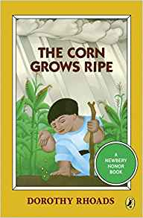  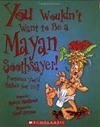 | Performance  Crucial Crew

