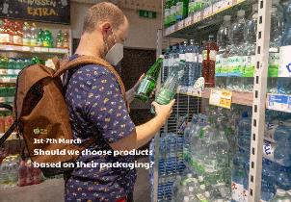 

What shape is used to package Pringles, Toblerones, cereal? These are all 3D shapes. When we open out a 3D shape flat, we call this a net. Can you open out a cereal packet (cuboid) and look at its net? Is it possible for the cereal packet to have a different net? Create the net of a cube. Find as many different ways of creating a cube as possible.

Design your own packaging. What product will your packaging contain? What is the purpose of the packaging? What shape will it be? What materials will you use? Will you consider the environment when you make your choice? What information will you include on it? What colours, patterns will you use? Draw a picture of your design and label it. If possible, make your packaging!

Use some of your waste packaging to do some junk modelling!

Find out how packaging has changed over time. Ask parents, grandparents or family friends what they remember about packaging.

Coca-Cola is a brand. Many brands use a logo which is recognisable. Look at some of the packaging in your home. Do you use any brands? Can you sketch their logos?

If possible, get some of your favourite drink. What does it look like? Can you describe its smell? Have a sip. What does it taste like? Draw a picture and describe your favourite drink.

**Learning from home**

Use the ideas below, alongside this week’s resource, to support your home learning.